CAPACITY BUILDING WORKSHOP
Quality Assurance through Self-Assessment Reports (SARs) Aligned with PREE Standards and Criteria Under PSG-2023
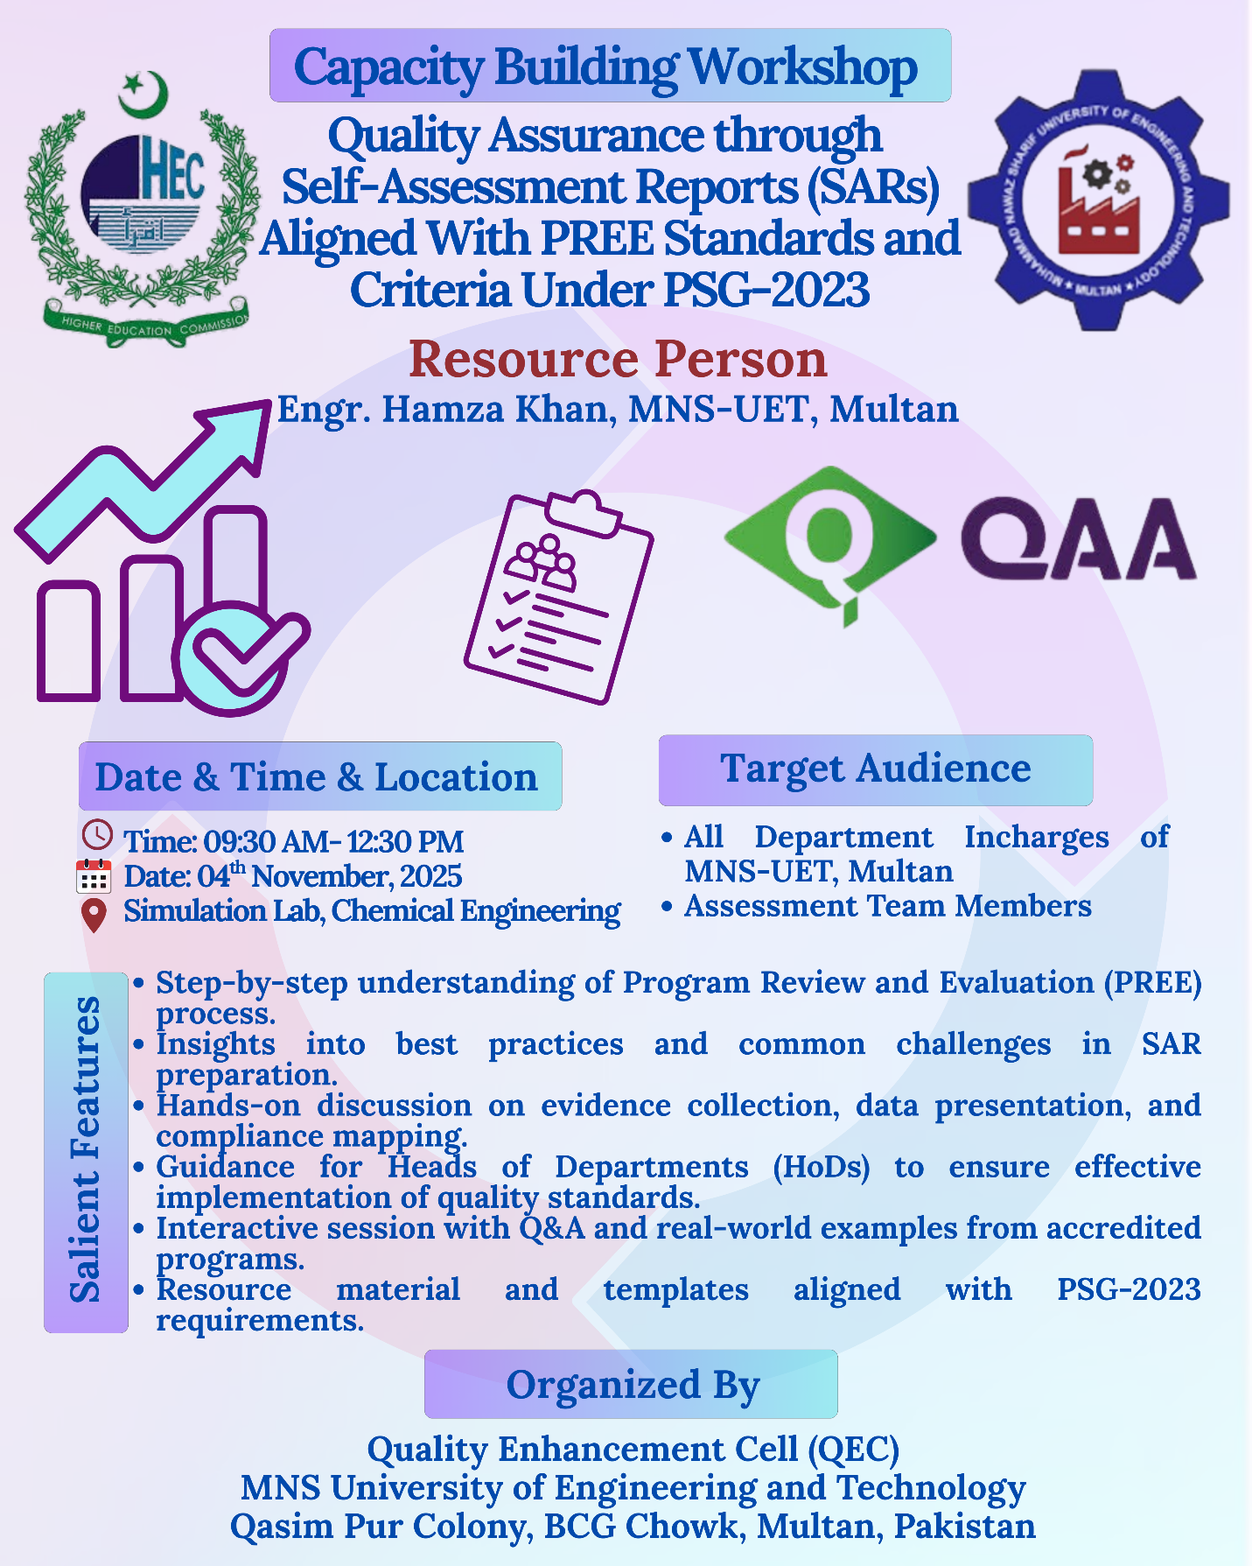
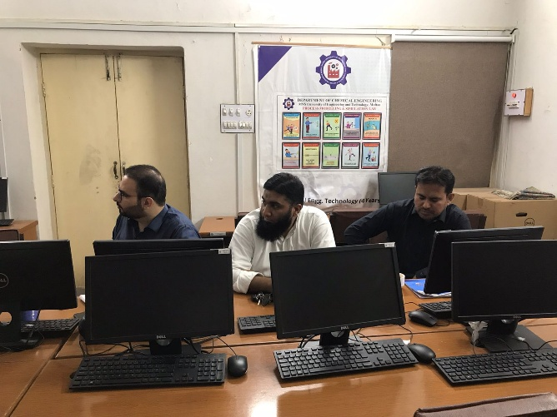 | 